Task on AWS CloudTrail, SNS & CloudWatch Monitoring

Task 1: Enable CloudTrail Monitoring and Store Events in S3 and CloudWatch Logs
Objective
To enable AWS CloudTrail for monitoring and recording API activity in the AWS account and store CloudTrail events in both Amazon S3 and CloudWatch Logs for auditing, monitoring, and security analysis.
Steps Performed
Step 1: Create an S3 bucket
- Open AWS Management Console.
- Search for S3.
- Click Create bucket.
- Enter a globally unique bucket name, for example:
cloudtrail-logs-sweety-2026
- Select the required AWS Region.
- Keep the default security settings.
- Click Create bucket.
Step 2: Create a CloudTrail trail
- Open CloudTrail.
- Go to Trails.
- Click Create trail.
- Enter a trail name:
My-CloudTrail
- Under Storage location, select Create new S3 bucket or select the bucket created above.
- Enable Log file validation if available.
- Under CloudWatch Logs, enable:
Send to CloudWatch Logs
- Create/select a CloudWatch Logs log group, for example:
/aws/cloudtrail/My-CloudTrail
- Create/select an IAM role that allows CloudTrail to send logs to CloudWatch.
- Under event types, enable Management events.
- Select:
  - Read events
  - Write events
- Click Create trail.
Evidence
Take screenshots of:
- CloudTrail → Trails showing My-CloudTrail as enabled.
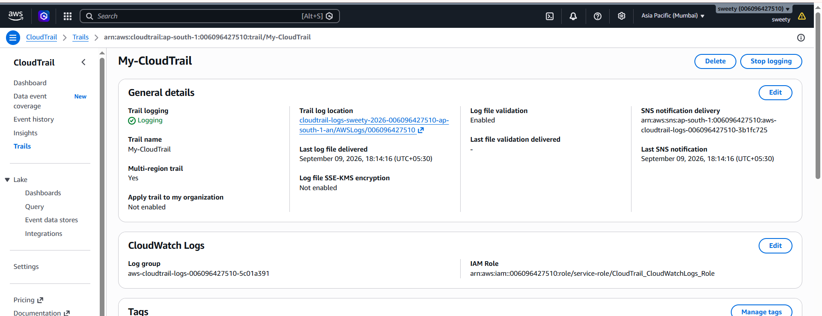
- CloudTrail trail configuration showing S3 destination.
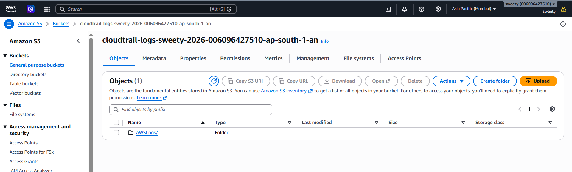
- CloudWatch Logs → Log groups showing:
/aws/cloudtrail/My-CloudTrail
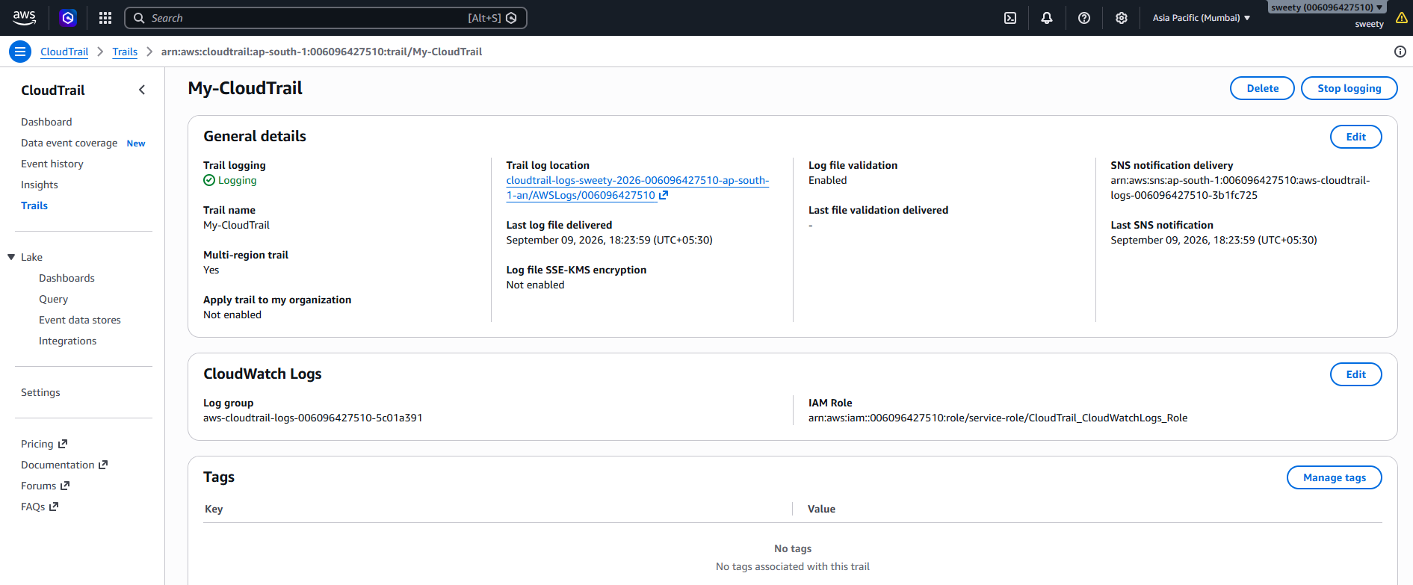

- S3 bucket showing CloudTrail log files.
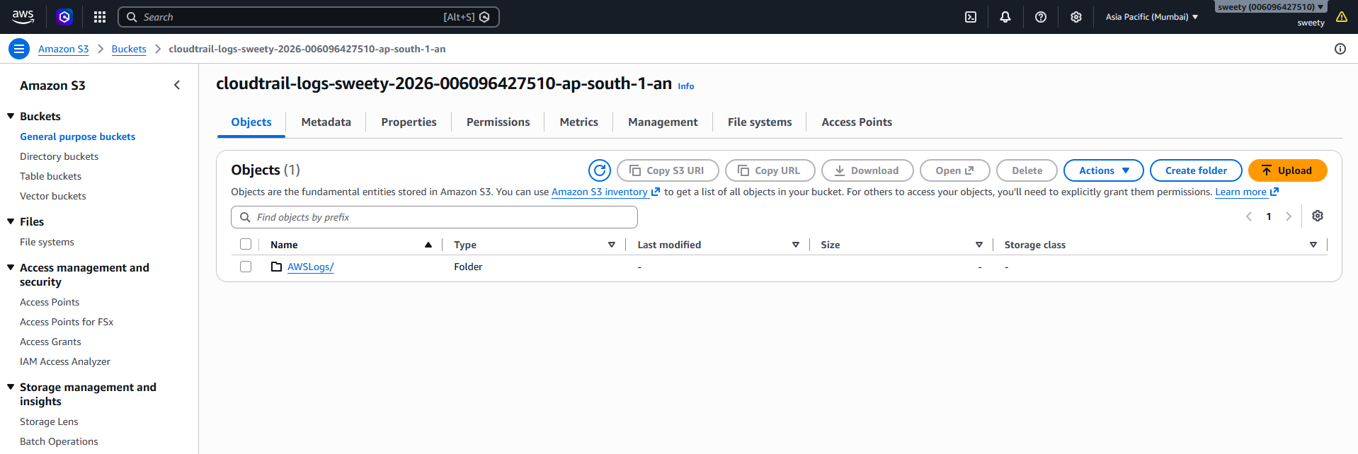
- CloudTrail Event history showing recorded events.
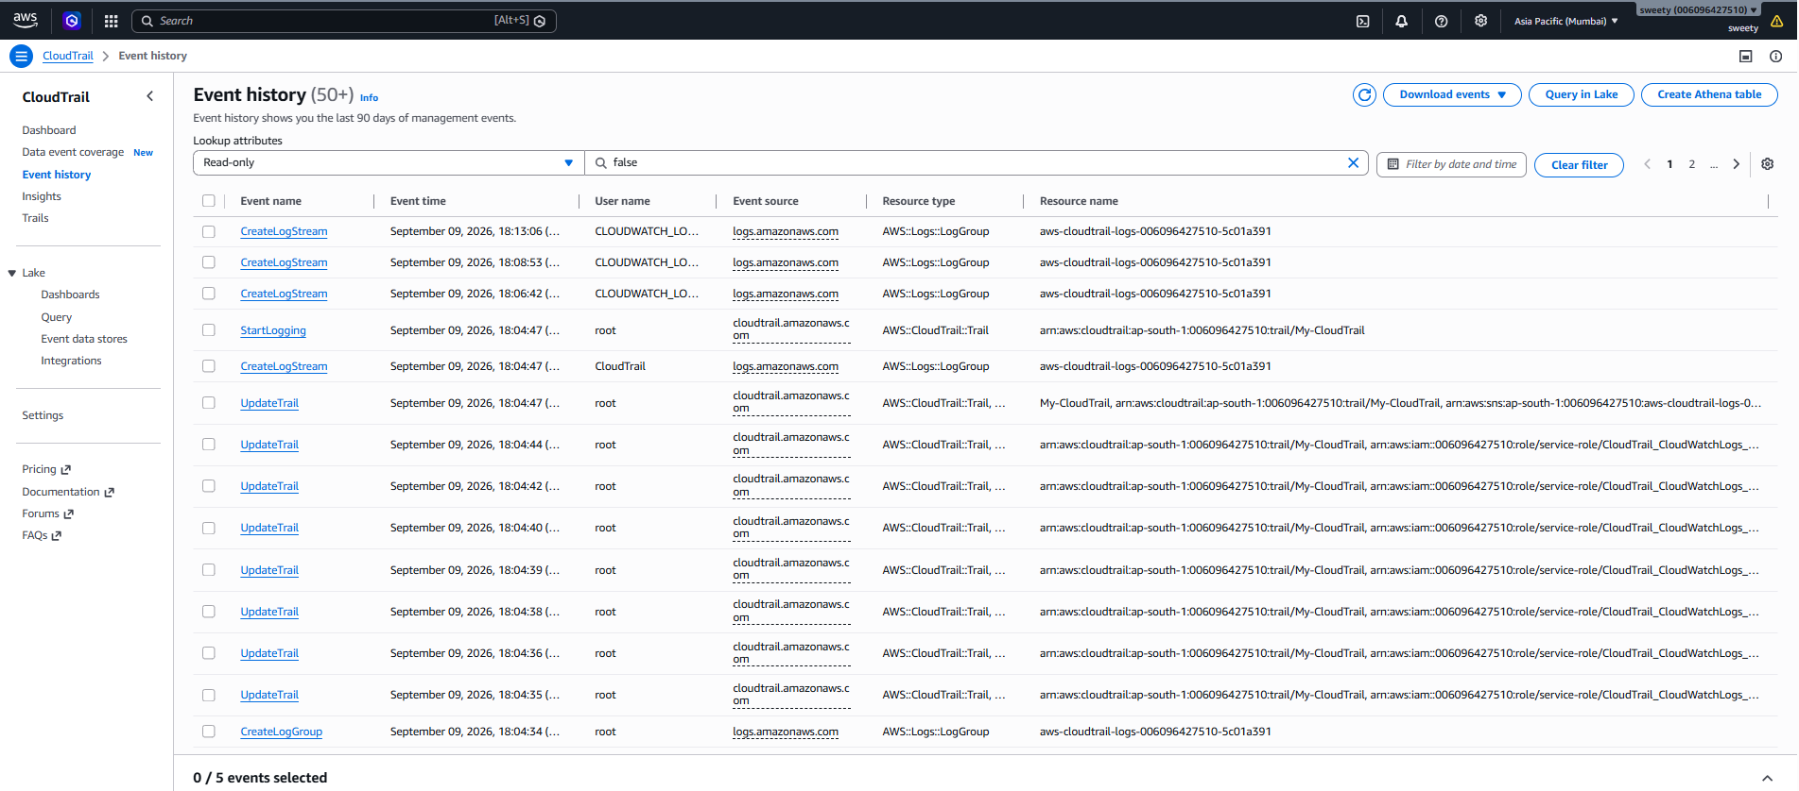
Conclusion
CloudTrail monitoring was successfully enabled. AWS API activity is recorded and stored in Amazon S3, while CloudTrail events are also delivered to CloudWatch Logs for centralized monitoring and analysis.

2. Enable SNS for CloudTrail to send alerts via email.
Objective
To configure Amazon SNS to send email notifications when specific CloudTrail events occur, providing real-time security and activity alerts.
Steps Performed
Step 1: Create an SNS topic
- Open Amazon SNS.
- Go to Topics.
- Click Create topic.
- Select Standard.
- Enter:
CloudTrailAlerts
- Click Create topic.
Step 2: Create an email subscription
- Open the CloudTrailAlerts topic.
- Click Create subscription.
- Protocol:
Email
- Enter your email address.
- Click Create subscription.
You will receive a confirmation email.
- Open the email.
- Click Confirm subscription.
Step 3: Connect CloudTrail/EventBridge to SNS
A practical way is to use Amazon EventBridge.
- Open Amazon EventBridge.
- Go to Rules.
- Click Create rule.
- Name it:
CloudTrailSecurityAlert
- Select Event pattern.
- Configure the pattern for the CloudTrail event you want to monitor.
For example, you could monitor important IAM activities such as:
CreateUser
DeleteUser
CreateAccessKey
DeleteAccessKey
AttachUserPolicy
- Select SNS topic as the target.
- Select:
CloudTrailAlerts
- Create the rule.
Step 4: Test
Perform the monitored AWS action, or use an appropriate test event.
The expected flow is:
AWS API Activity
↓
CloudTrail
↓
EventBridge
↓
SNS
↓
Email
Evidence
Take screenshots of:
- SNS topic CloudTrailAlerts
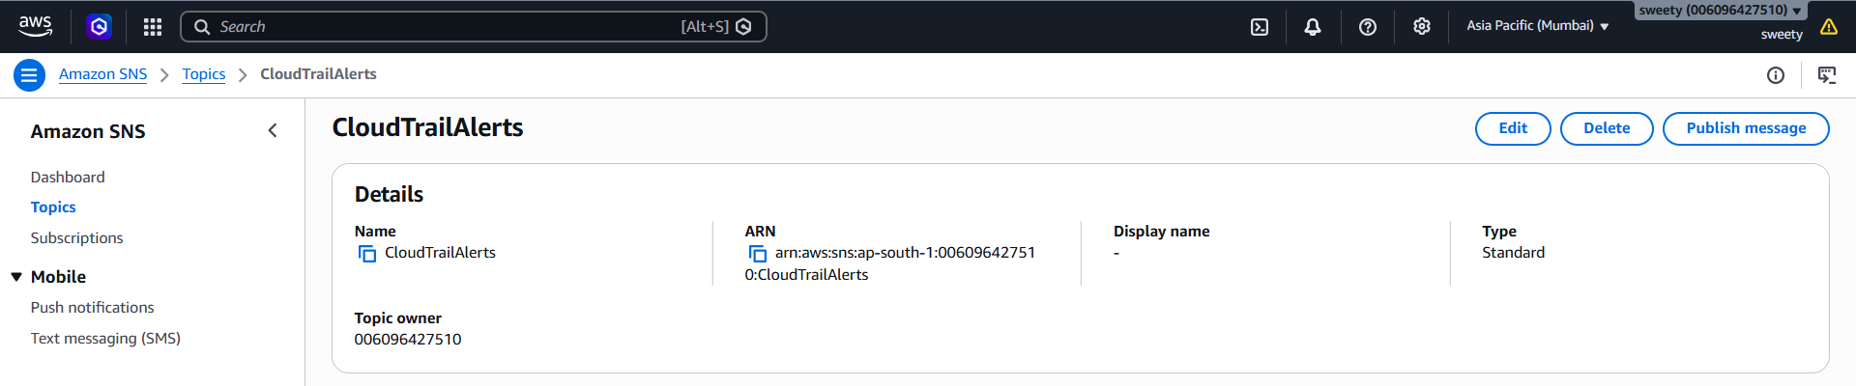
- SNS subscription showing Confirmed.
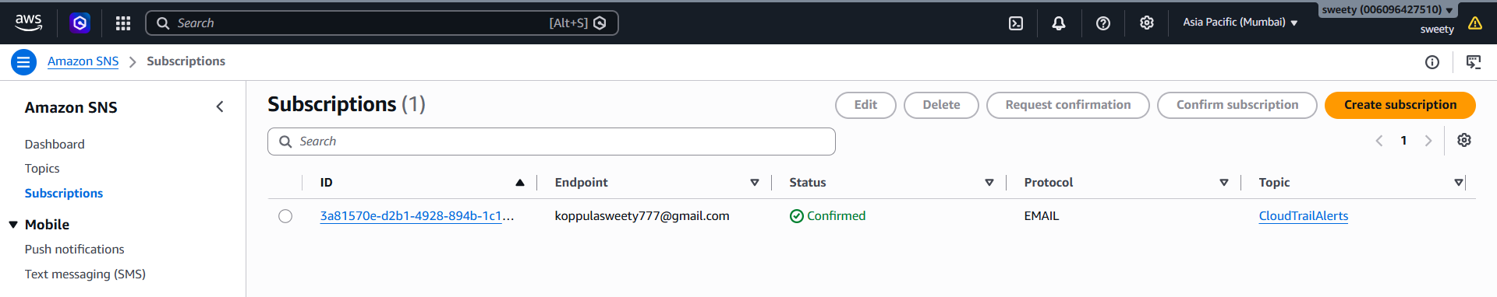
- EventBridge rule.
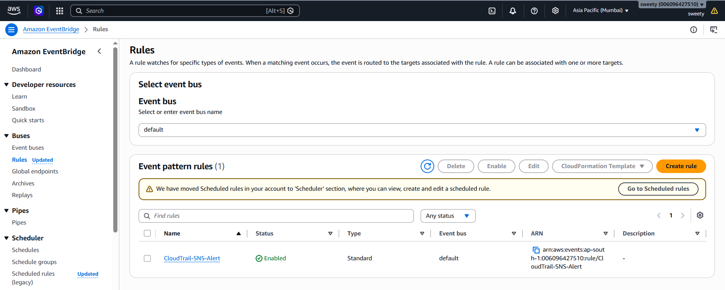

- Event pattern.
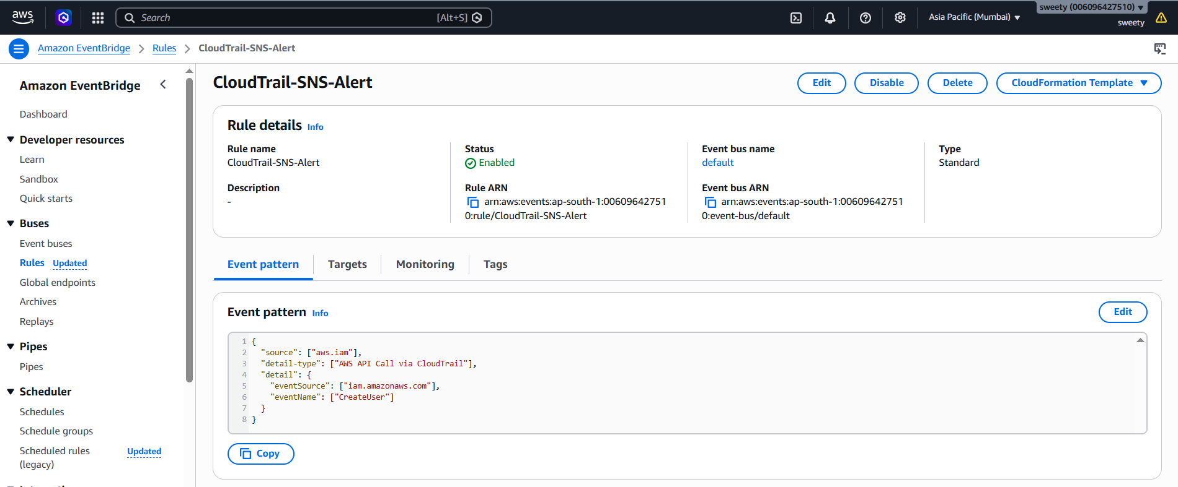
- SNS target configured in the rule.
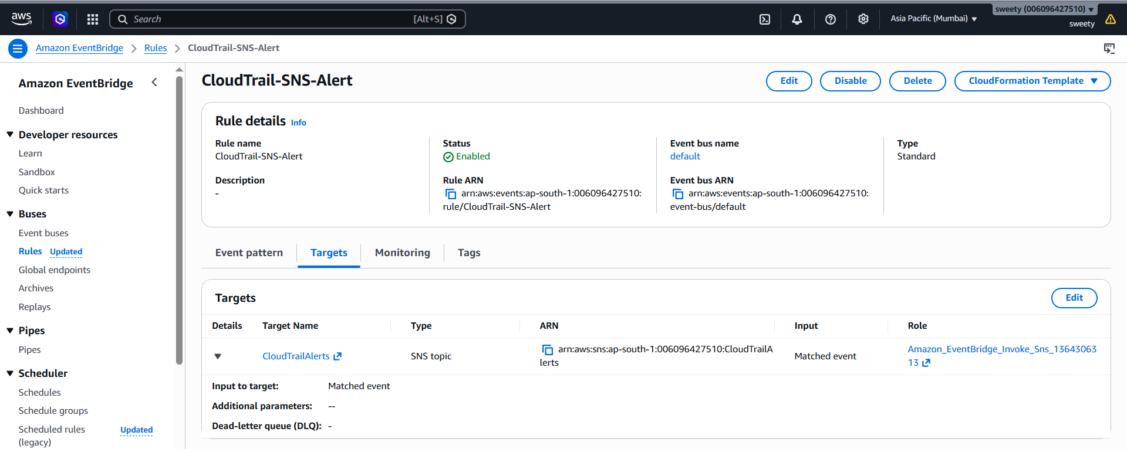
- Email alert received in your inbox.
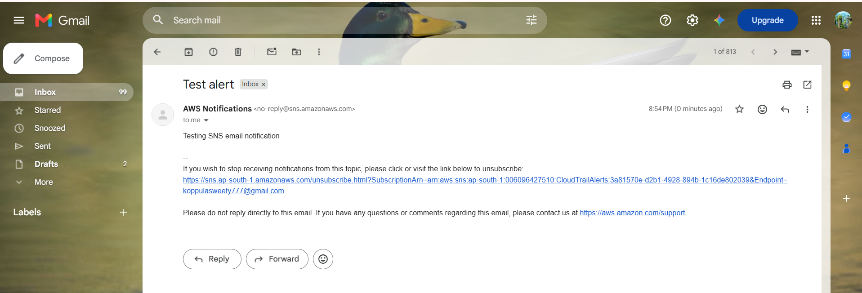
Conclusion
SNS email notifications were successfully configured for CloudTrail-related events. The configuration allows important AWS activities to generate email alerts for improved security monitoring.

3. Configure CloudWatch monitoring and record the CPU utilization and other metrics of EC2.
Objective
To configure Amazon CloudWatch monitoring for an EC2 instance and monitor important performance metrics such as CPU utilization, network traffic, disk-related metrics, and status checks.
Steps Performed
- Open AWS Console.
- Go to EC2.
- Select the required EC2 instance.
- Note the Instance ID.
For example:
i-xxxxxxxxxxxxxxxxx
- Open CloudWatch.
- Go to:
Metrics → All metrics → EC2
- Select:
Per-Instance Metrics
- Search for your instance ID.
You should see metrics such as:
CPUUtilization
NetworkIn
NetworkOut
StatusCheckFailed
StatusCheckFailed_Instance
StatusCheckFailed_System
Important Point
For many basic EC2 metrics, AWS automatically sends metrics to CloudWatch.
For more detailed OS-level information such as:
- Memory utilization
- Disk utilization
- Processes
- Service status
you normally need to install and configure the CloudWatch Agent.
Evidence
Take screenshots showing:
- EC2 instance ID.
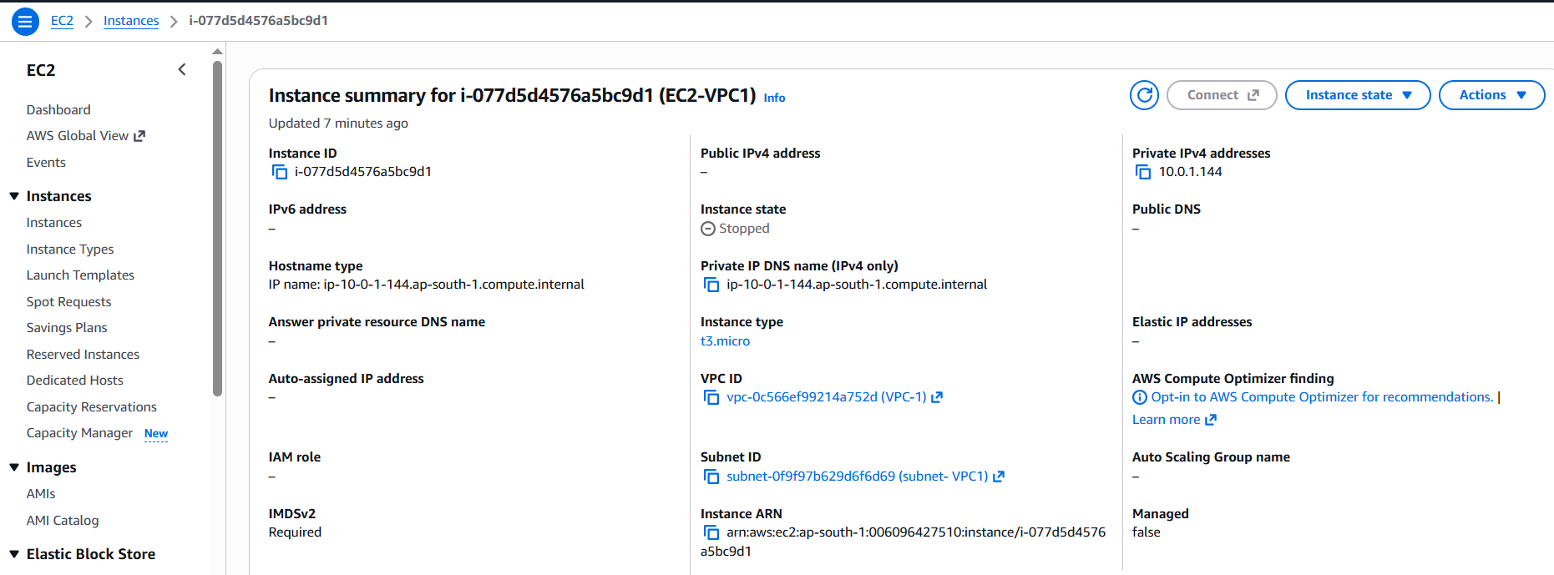
- CloudWatch → Metrics → EC2.
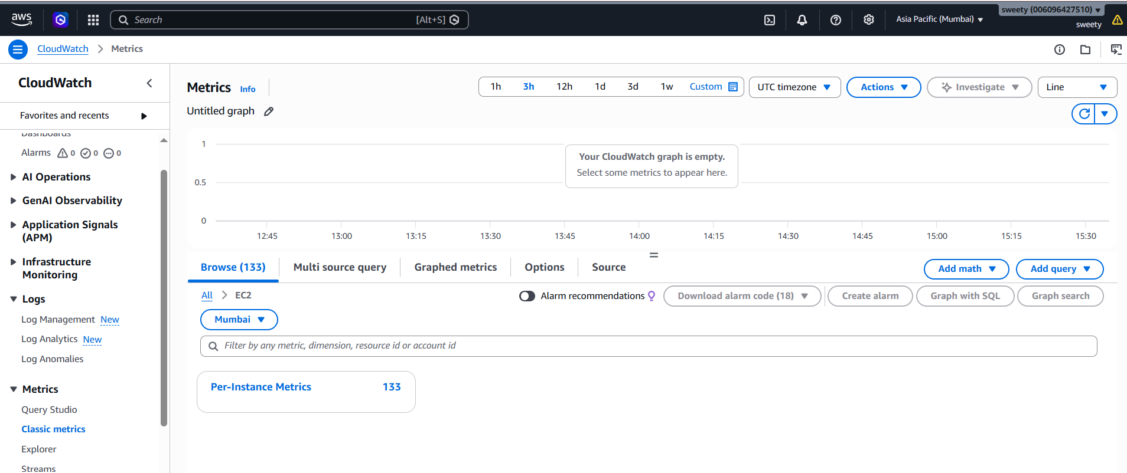
- CPUUtilization graph.
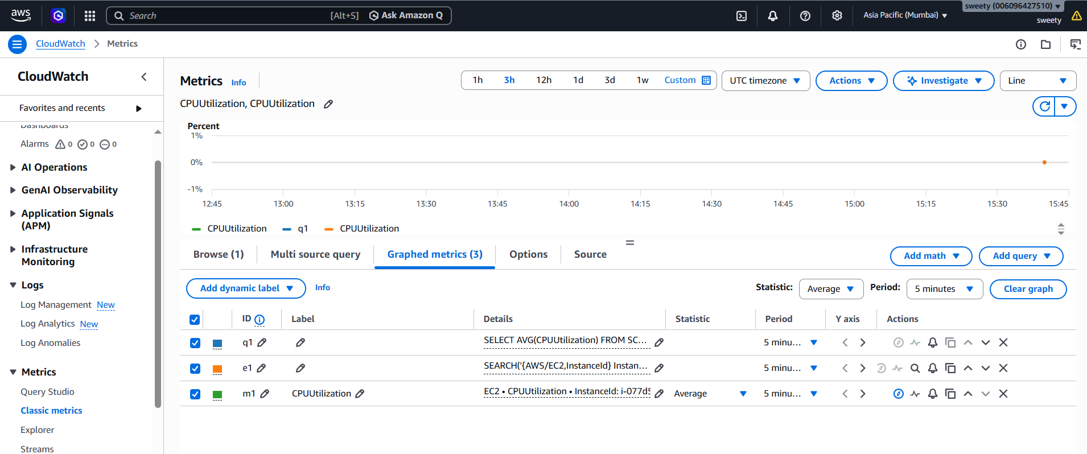
- Other EC2 metrics such as:
  - NetworkIn
  - NetworkOut
  - StatusCheckFailed
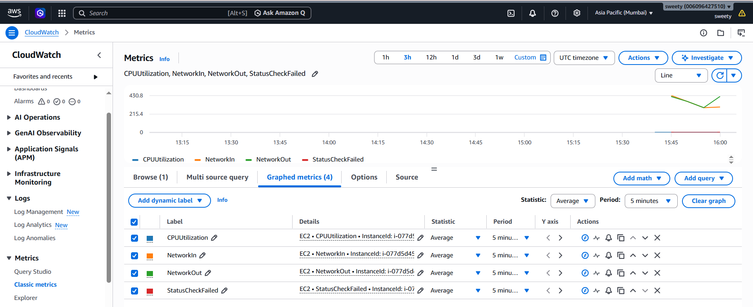
Conclusion
CloudWatch monitoring was successfully configured for the EC2 instance. CPU utilization and other available EC2 performance metrics can now be monitored through CloudWatch.

4. Create an Alarm if CPU Utilization Exceeds 70%
Objective
To create a CloudWatch alarm that monitors EC2 CPU utilization and sends an email notification through SNS when CPU utilization exceeds 70%.
Steps Performed
Step 1: Create SNS topic
If you already created the SNS topic in Task 2, you can reuse it.
Otherwise:
- Open SNS.
- Create topic:
EC2CPUAlerts
- Create an Email subscription.
- Confirm the subscription from your email.
Step 2: Create CloudWatch alarm
- Open CloudWatch.
- Go to:
Alarms → All alarms
- Click Create alarm.
- Click Select metric.
- Select:
EC2
→ Per-Instance Metrics
→ CPUUtilization
- Select your EC2 instance.
Step 3: Configure the threshold
Set:
Statistic: Average
Period: 5 minutes
Threshold type: Static
Condition: Greater than
Threshold: 70
So the condition becomes:
CPUUtilization > 70%
You can configure the evaluation period according to your task requirements.
Step 4: Configure notification
Under Alarm state trigger, select:
In alarm
Under notification:
Send notification to SNS topic
Select:
EC2CPUAlerts
Step 5: Name the alarm
For example:
EC2-CPU-Above-70
Click Create alarm.
Alarm Flow
EC2 Instance
↓
CPU Utilization
↓
CloudWatch
↓
CPU > 70%
↓
CloudWatch Alarm
↓
SNS
↓
Email
Evidence
Take screenshots of:
- CPUUtilization metric.
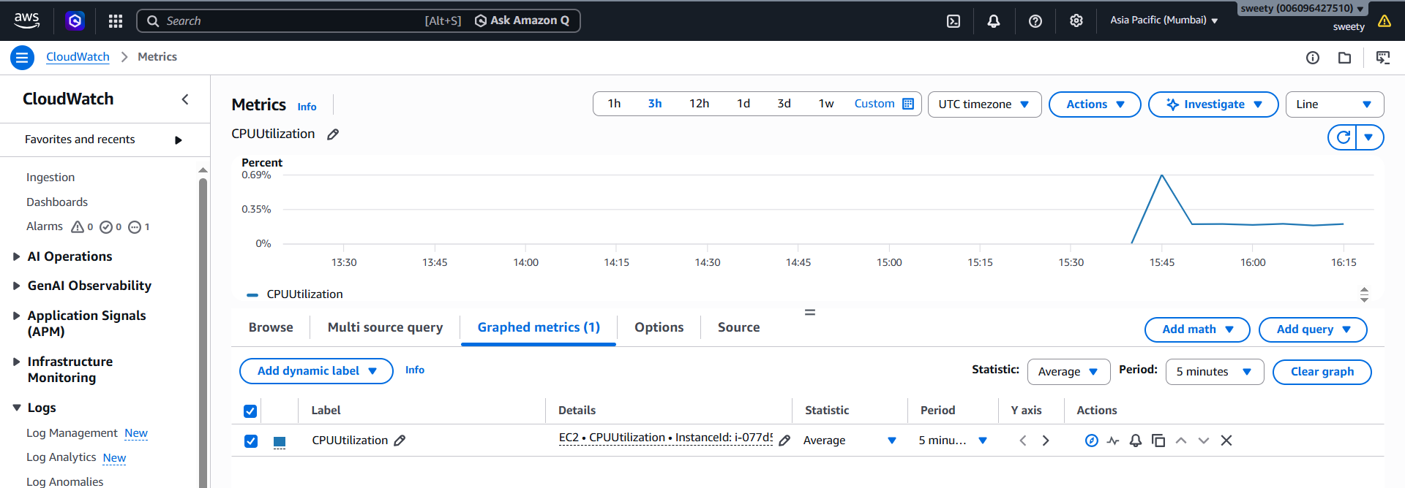
- Alarm configuration.
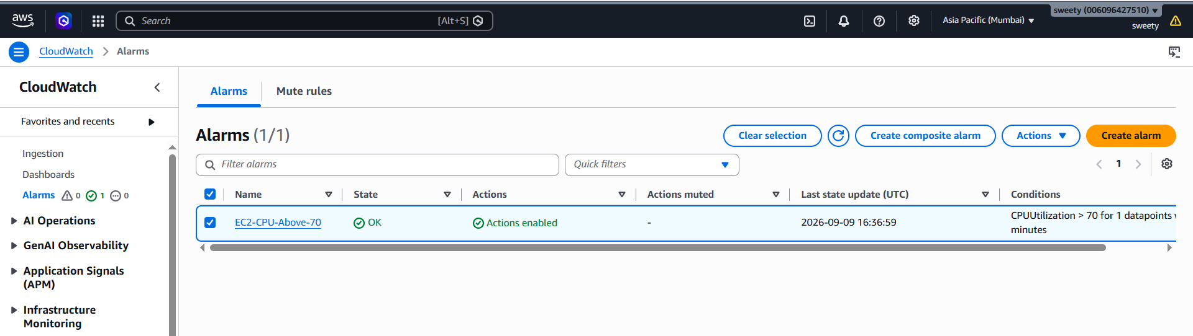
- Threshold showing:
CPUUtilization > 70%
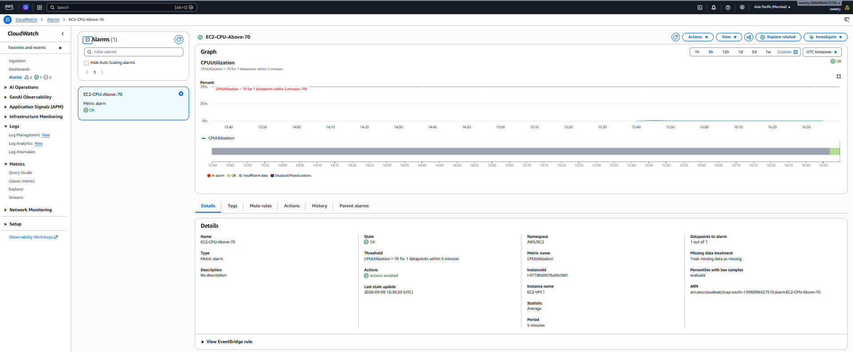

- SNS notification configuration.
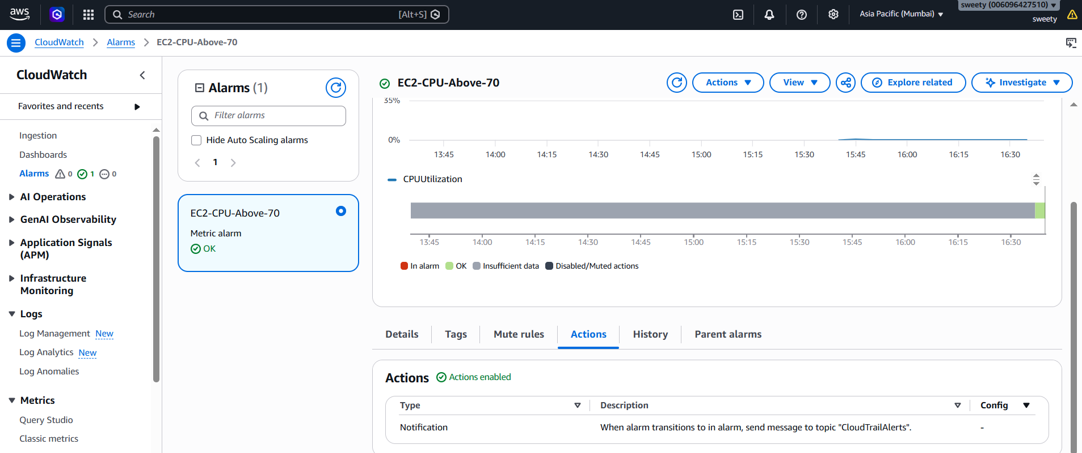
- Alarm list showing:
EC2-CPU-Above-70
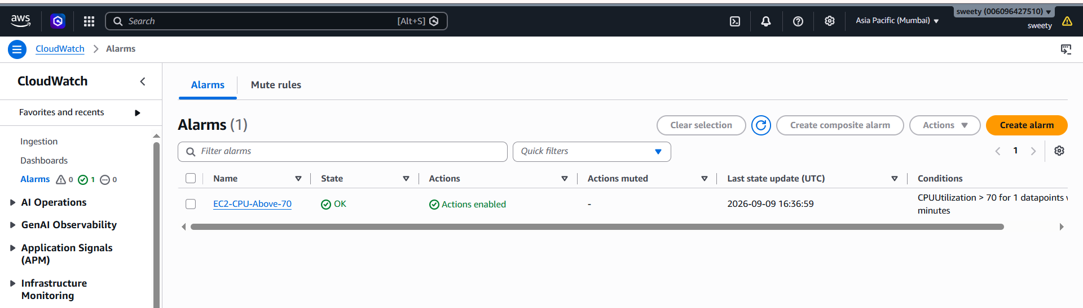
Conclusion
A CloudWatch CPU alarm was successfully created. When the EC2 instance CPU utilization exceeds 70%, CloudWatch changes the alarm state and SNS sends an email notification.

5. Create Dashboard to Monitor Tomcat Service and Send Alert
Objective
To monitor the Tomcat service running on an EC2 instance using CloudWatch and create a dashboard and alert that indicates when the Tomcat service is not running.
Important
This task requires more than the standard EC2 CPU metrics.
You need to publish Tomcat service status to CloudWatch.
A simple approach is:
Tomcat
↓
Monitoring script
↓
CloudWatch Agent / AWS CLI
↓
Custom CloudWatch Metric
↓
CloudWatch Alarm
↓
SNS Email
Step 1: Verify Tomcat
On the EC2 server:
sudo systemctl status tomcat
If your service has a different name, check:
sudo systemctl list-units --type=service | grep -i tomcat
For example:
tomcat.service
Step 2: Create a monitoring script
For example:
#!/bin/bash

if systemctl is-active --quiet tomcat; then
STATUS=1
else
STATUS=0
fi

aws cloudwatch put-metric-data \
--namespace "Custom/Tomcat" \
--metric-name "TomcatServiceStatus" \
--value $STATUS \
--unit Count
The meaning is:
1 = Tomcat running
0 = Tomcat stopped
Make the script executable:
chmod +x tomcat-monitor.sh
Step 3: Test the metric
Run:
./tomcat-monitor.sh
Then open:
CloudWatch → Metrics → Custom namespaces → Custom/Tomcat
You should see:
TomcatServiceStatus
Step 4: Create CloudWatch alarm
Create an alarm using:
Metric:
TomcatServiceStatus

Condition:
Less than 1
This means:
Tomcat status = 0
↓
Tomcat is not running
↓
CloudWatch Alarm
↓
SNS
↓
Email
Name it:
Tomcat-Service-Down
Step 5: Create CloudWatch Dashboard
- Open CloudWatch.
- Go to Dashboards.
- Click Create dashboard.
- Name it:
EC2-Service-Monitoring
- Add the TomcatServiceStatus metric.
- Add useful EC2 metrics such as:
  - CPUUtilization
  - NetworkIn
  - NetworkOut
  - StatusCheckFailed
- Save the dashboard.
Step 6: Test
Stop Tomcat:
sudo systemctl stop tomcat
Run the monitoring script again:
./tomcat-monitor.sh
CloudWatch should eventually receive:
TomcatServiceStatus = 0
The alarm should enter:
ALARM
and SNS should send an email.
Then start Tomcat again:
sudo systemctl start tomcat
Evidence
Take screenshots of:
- Tomcat running:
systemctl status tomcat 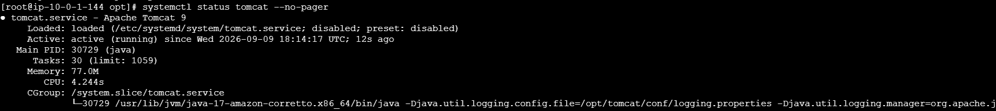
- CloudWatch custom metric TomcatServiceStatus
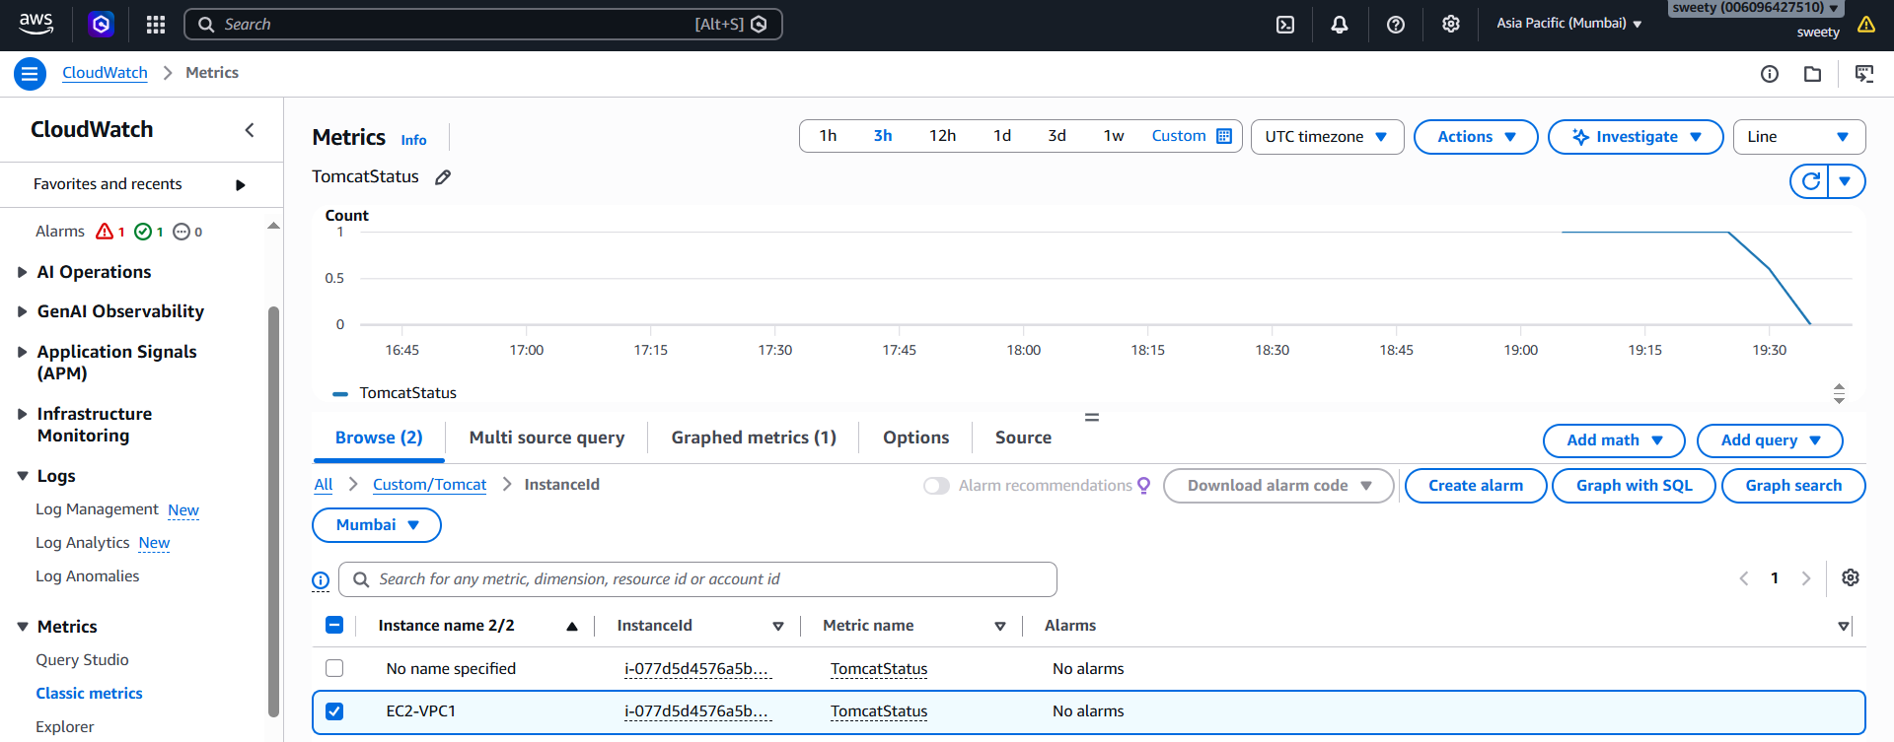

- CloudWatch dashboard.
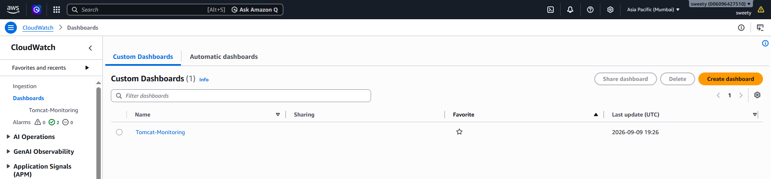
- Tomcat CloudWatch alarm.
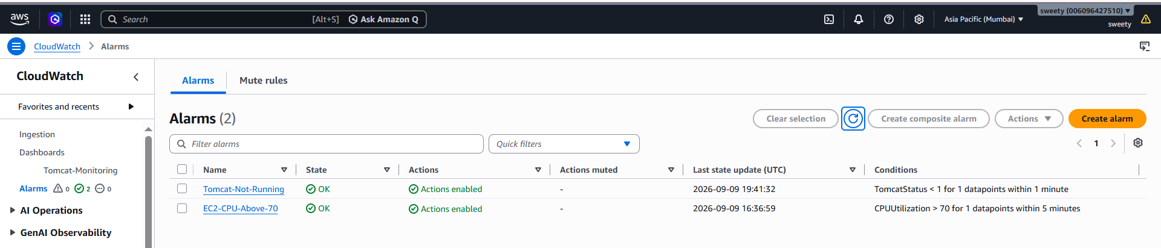

- Alarm configuration showing < 1.
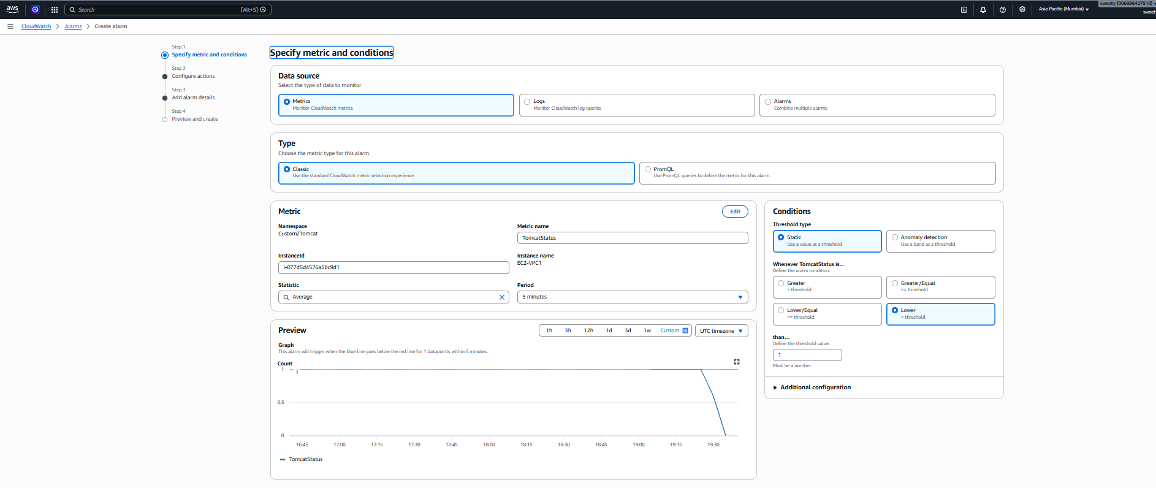
- SNS email received after stopping Tomcat.
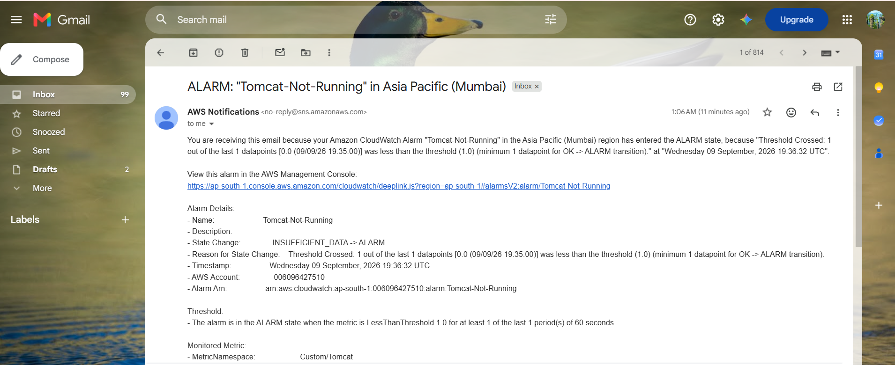

Conclusion
Tomcat service monitoring was configured using a custom CloudWatch metric. A CloudWatch dashboard displays the Tomcat service status, and an alarm sends an SNS email notification when the Tomcat service becomes unavailable.

6. Create Dashboard to Monitor Nginx and Send Alert if It Stops
Objective
To monitor the Nginx service running on an EC2 instance using CloudWatch and create a dashboard and alert that sends an email when Nginx is not running.
Step 1: Verify Nginx
Run:
sudo systemctl status nginx
Check the service name if required:
sudo systemctl list-units --type=service | grep -i nginx
Step 2: Create Nginx monitoring script
Create:
vi nginx-monitor.sh
Add:
#!/bin/bash

if systemctl is-active --quiet nginx; then
STATUS=1
else
STATUS=0
fi

aws cloudwatch put-metric-data \
--namespace "Custom/Nginx" \
--metric-name "NginxServiceStatus" \
--value $STATUS \
--unit Count
Make it executable:
chmod +x nginx-monitor.sh
Run:
./nginx-monitor.sh
Step 3: Check CloudWatch metric
Go to:
CloudWatch → Metrics → Custom Namespaces → Custom/Nginx
You should see:
NginxServiceStatus
Where:
1 = Nginx running
0 = Nginx stopped
Step 4: Create CloudWatch alarm
Create an alarm with:
Metric:
NginxServiceStatus

Condition:
Less than 1
Name:
Nginx-Service-Down
Set the SNS notification to your email topic.
Step 5: Add Nginx to dashboard
Open:
CloudWatch → Dashboards → EC2-Service-Monitoring
Add:
NginxServiceStatus
You can also add:
CPUUtilization
NetworkIn
NetworkOut
Your dashboard can therefore show:
Metric | Meaning
CPUUtilization | EC2 CPU usage
NetworkIn | Incoming network traffic
NetworkOut | Outgoing network traffic
TomcatServiceStatus | Tomcat status
NginxServiceStatus | Nginx status
Step 6: Test Nginx alert
Stop Nginx:
sudo systemctl stop nginx
Run:
./nginx-monitor.sh
CloudWatch receives:
NginxServiceStatus = 0
The alarm should eventually become:
ALARM
SNS then sends an email.
Start Nginx again:
sudo systemctl start nginx
Run the monitoring script again:
./nginx-monitor.sh
The metric should return to:
1
and the alarm should eventually return to:
OK
Evidence
Take screenshots of:
- Nginx running using:
systemctl status nginx
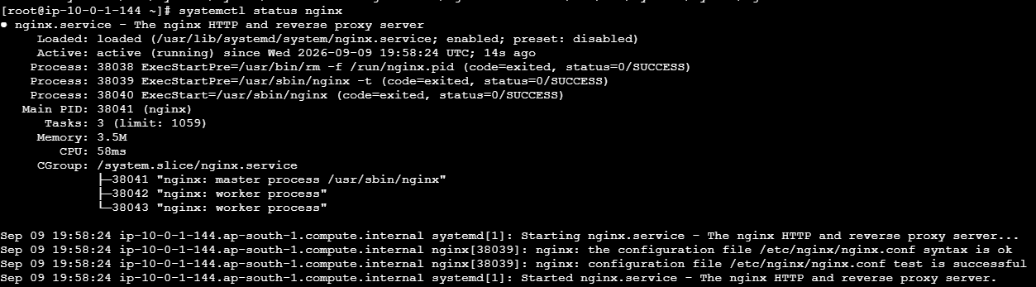

- CloudWatch dashboard containing Nginx status.
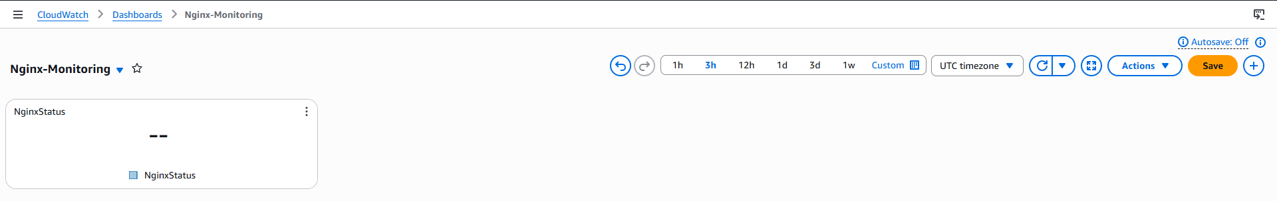
- Nginx-Service-Down alarm.
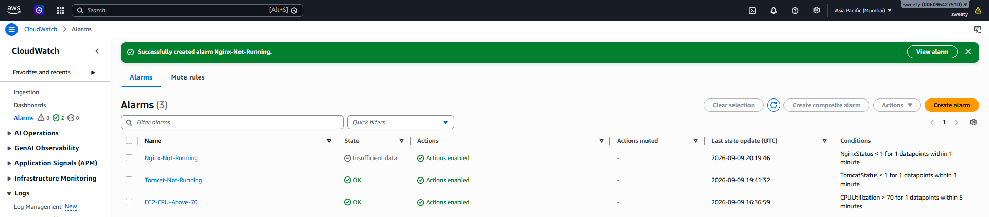
- Alarm threshold showing < 1.
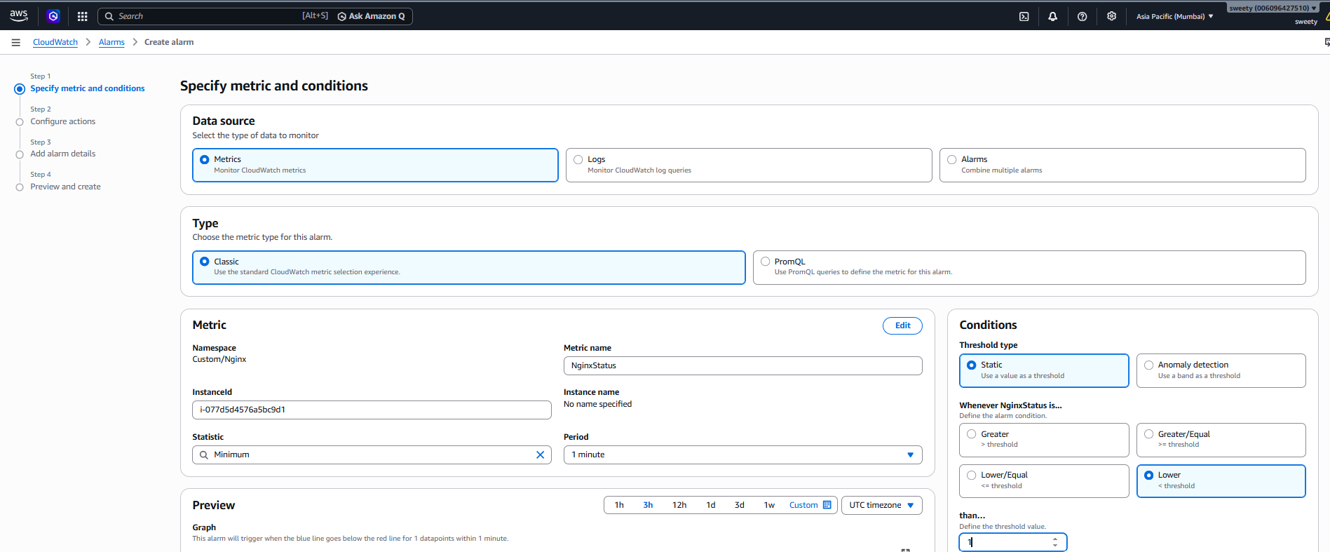
- SNS email received after stopping Nginx.
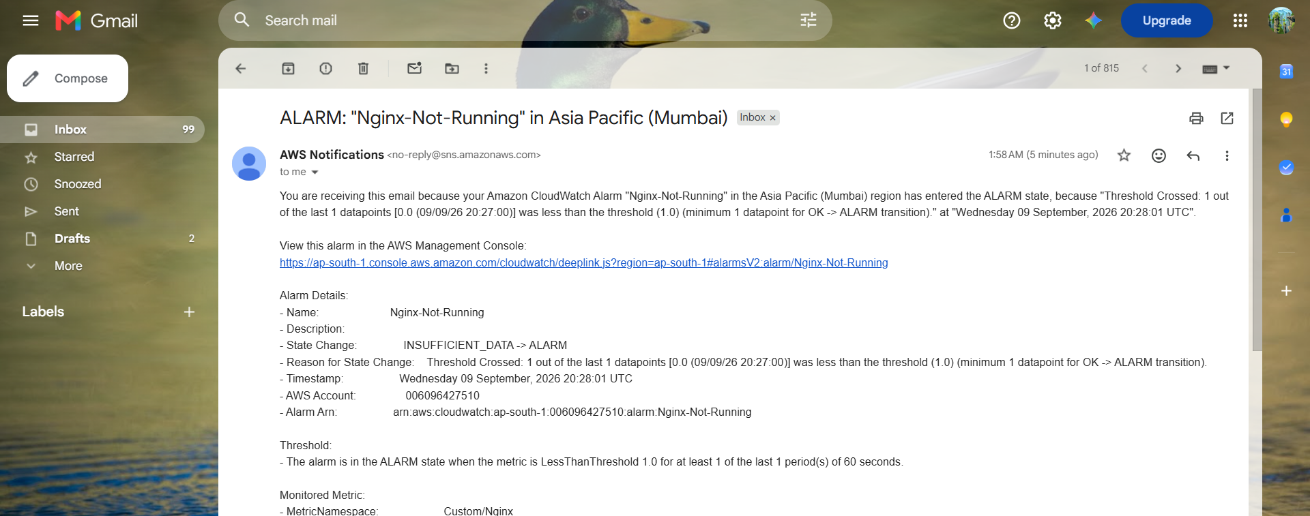

- Alarm returning to OK after restarting Nginx.
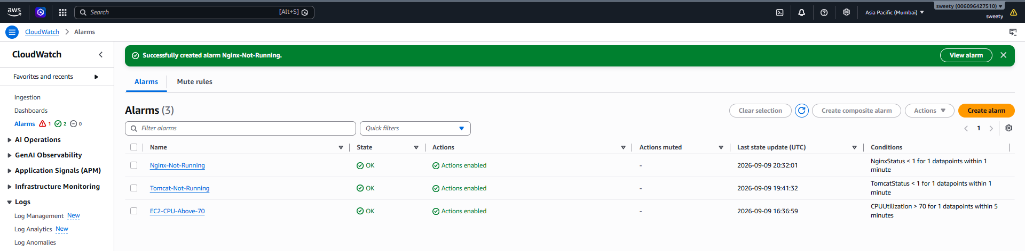
Conclusion
Nginx service monitoring was successfully configured using a custom CloudWatch metric. The CloudWatch dashboard displays the Nginx service status, and an alarm sends an email notification through SNS whenever Nginx stops running.

